<<Service/Support Unit Name>>

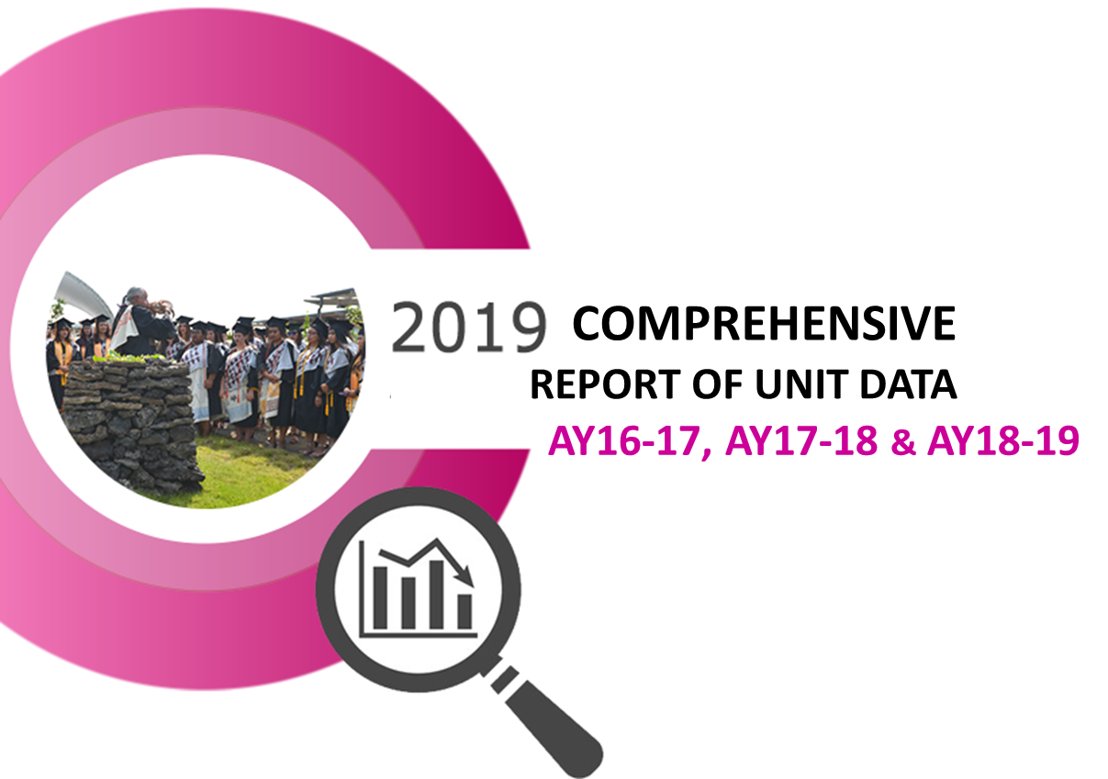

1. Unit Description
Description of the unit from the catalog or other public materials.

2. Analysis of the Unit
For the three-year review period, discuss the unit’s strengths and weaknesses in terms of demand, efficiency and effectiveness based on an analysis of the unit’s data.

Include Significant Unit Actions and results of the unit’s three previous consecutive annual action plans.

3. Unit Outcomes (UOs) & Student Learning Outcomes (SLOs)
- List of the Unit Outcomes and, as applicable, Student Learning Outcomes (SLOs) with their alignment to the College’s Institutional Learning Outcomes (ILOs).
- UOs/SLOs that have been assessed during the three-year review period.
- Discussion of the unit’s UO/SLO assessment results.
- Discussion of the unit’s strengths and challenges in meeting its service/support goals, and changes that have been made as a result of assessments.

4. Action Plan
Provide a detailed action plan to improve the unit’s success in its service and support operations over the next three years. Discuss how the action items within the plan support the collegeʻs Mission with specific reference to the Strategic Directions plan: HawCC Strategic Directions Plan 2015-2021.pdf

5. Resource Implications
(physical, human, financial)
Provide a detailed discussion of the unit’s current resources, resource gaps and requests for new or re-allocated resources. Provide detailed documentation for each resource request including projected costs and timeline for procurement to meet the unit’s needs. Resource requests must align to and support the action plan above.
Attach additional documentation and evidence as necessary to clearly support each request.

